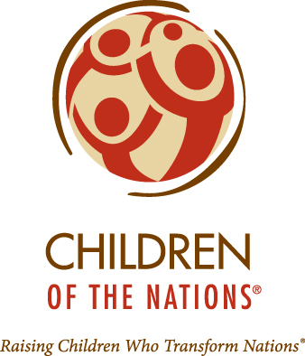
Children of the Nations
Haiti Physical Care Program

$ 5,000

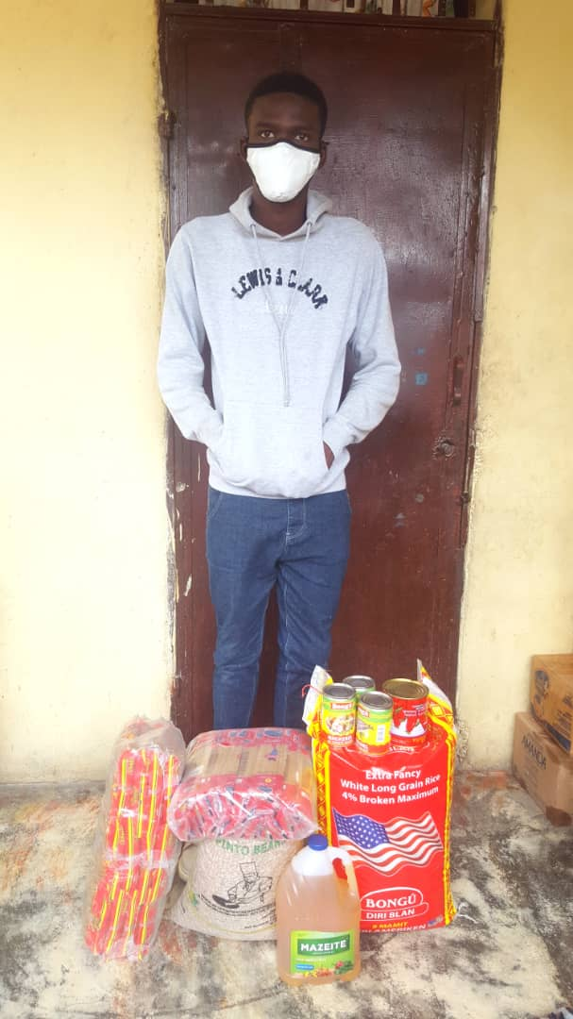

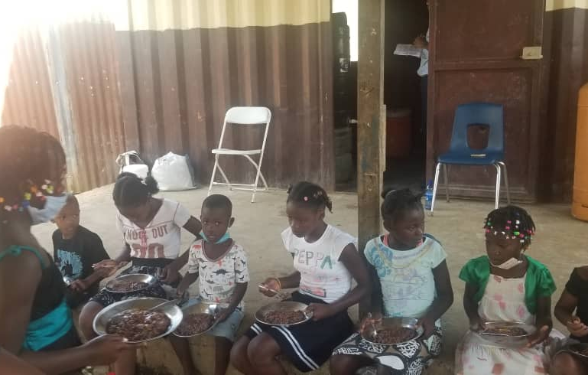

Haiti Children of the Nations’ mission provides holistic, Christ-centered care for orphaned and destitute children, enabling them to create positive and lasting change in their nations. To help children stay healthy and avoid physical ailments, the Haiti Physical Care Program makes sure all 113 Village Partnership Program children receive the services such as: • Individualized care plans and referrals for complex medical needs • Daily balanced, nutritious meals • Annual training and certification for clinic staff • Patient/child safety measures implemented in the clinic • Growth charts • Bi-annual deworming medications • Mosquito nets

2022-2024 Biennium – LWML Washington-Alaska District

